Erasmus+ project “The Citizen of the Future Facing Climatic Change (COFFE_E)”

For the PROJECT LEAFLET.

1. Could you, please, write the information to the leaflet about your school. The word number should be 100-120.
2. Will You send us Your school photo - the general view and a good quality?
3. Your school Logo and website address are also necessary.

Thank You in advance.

LICEUL TEHNOLOGIC DACIA
Pitesti
Romania
http://liceultehnologicdaciapitesti.info/

The Dacia Technological High School was established in 1967. Pitesti is situated in the historical region of Muntenia, Romania.
There are 59 teachers and 809 students. This school offers courses of secondary, vocational and post - secondary education levels. It provides students with knowledge of engineering and car construction. After graduation students can work for the biggest car production in Dacia Group Renault, South Europe and other European countries. In recent years an important objective was implementation and organization of educational projects at European level. It has pursued the promotion of European values at the level of school unity, as well as improving the quality of education provided, ensuring the European dimension in the field of education and training. The objective is to stimulate new, smart, inclusive growth through the use of digital economy.

Coordinator of the project – Ionita Iuliana
Coordinators of the Romanian team – Ionita Iuliana & Soare Angelica

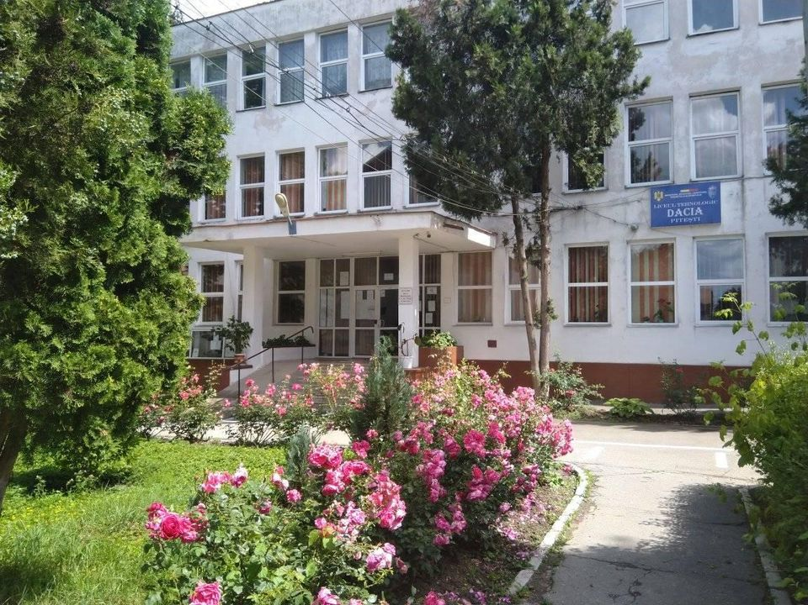
School logo
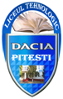

Erasmus+ project “The Citizen of the Future Facing Climatic Change (COFFE_E)”

For the PROJECT LEAFLET.

PANEVĖŽIO 5-OJI GIMNAZIJA
Panevėžys
Lithuania
https://penktoji.panevezys.lm.lt

The school was founded in 1918. It is situated in Panevėžys - the fifth largest city in Lithuania.
There are 60 teachers and 650 students aged 15-19. It is a four year secondary providing basic and advanced knowledge in all the subjects: languages and humanities, sciences, nature studies, history and citizenship, computer studies, art (music, dancing,drawing). For the last two years students choose one of 3 profiles and study for the state exams to enter a university or a college in Lithuania or in a foreign country.
Students participate in various activities: photography, school choir, music studio, sports, IT, robotics, art, newspaper reporting, scouts, Parliament events, debate club after the lessons.
The goal is to maintain high standards, to apply modern and innovative methods in educating and motivating students to achieve good results in academic and extracurricular activities and to add to intellectual growth.

Coordinator of the Lithuanian team – Jolita Stankevičienė

School photo
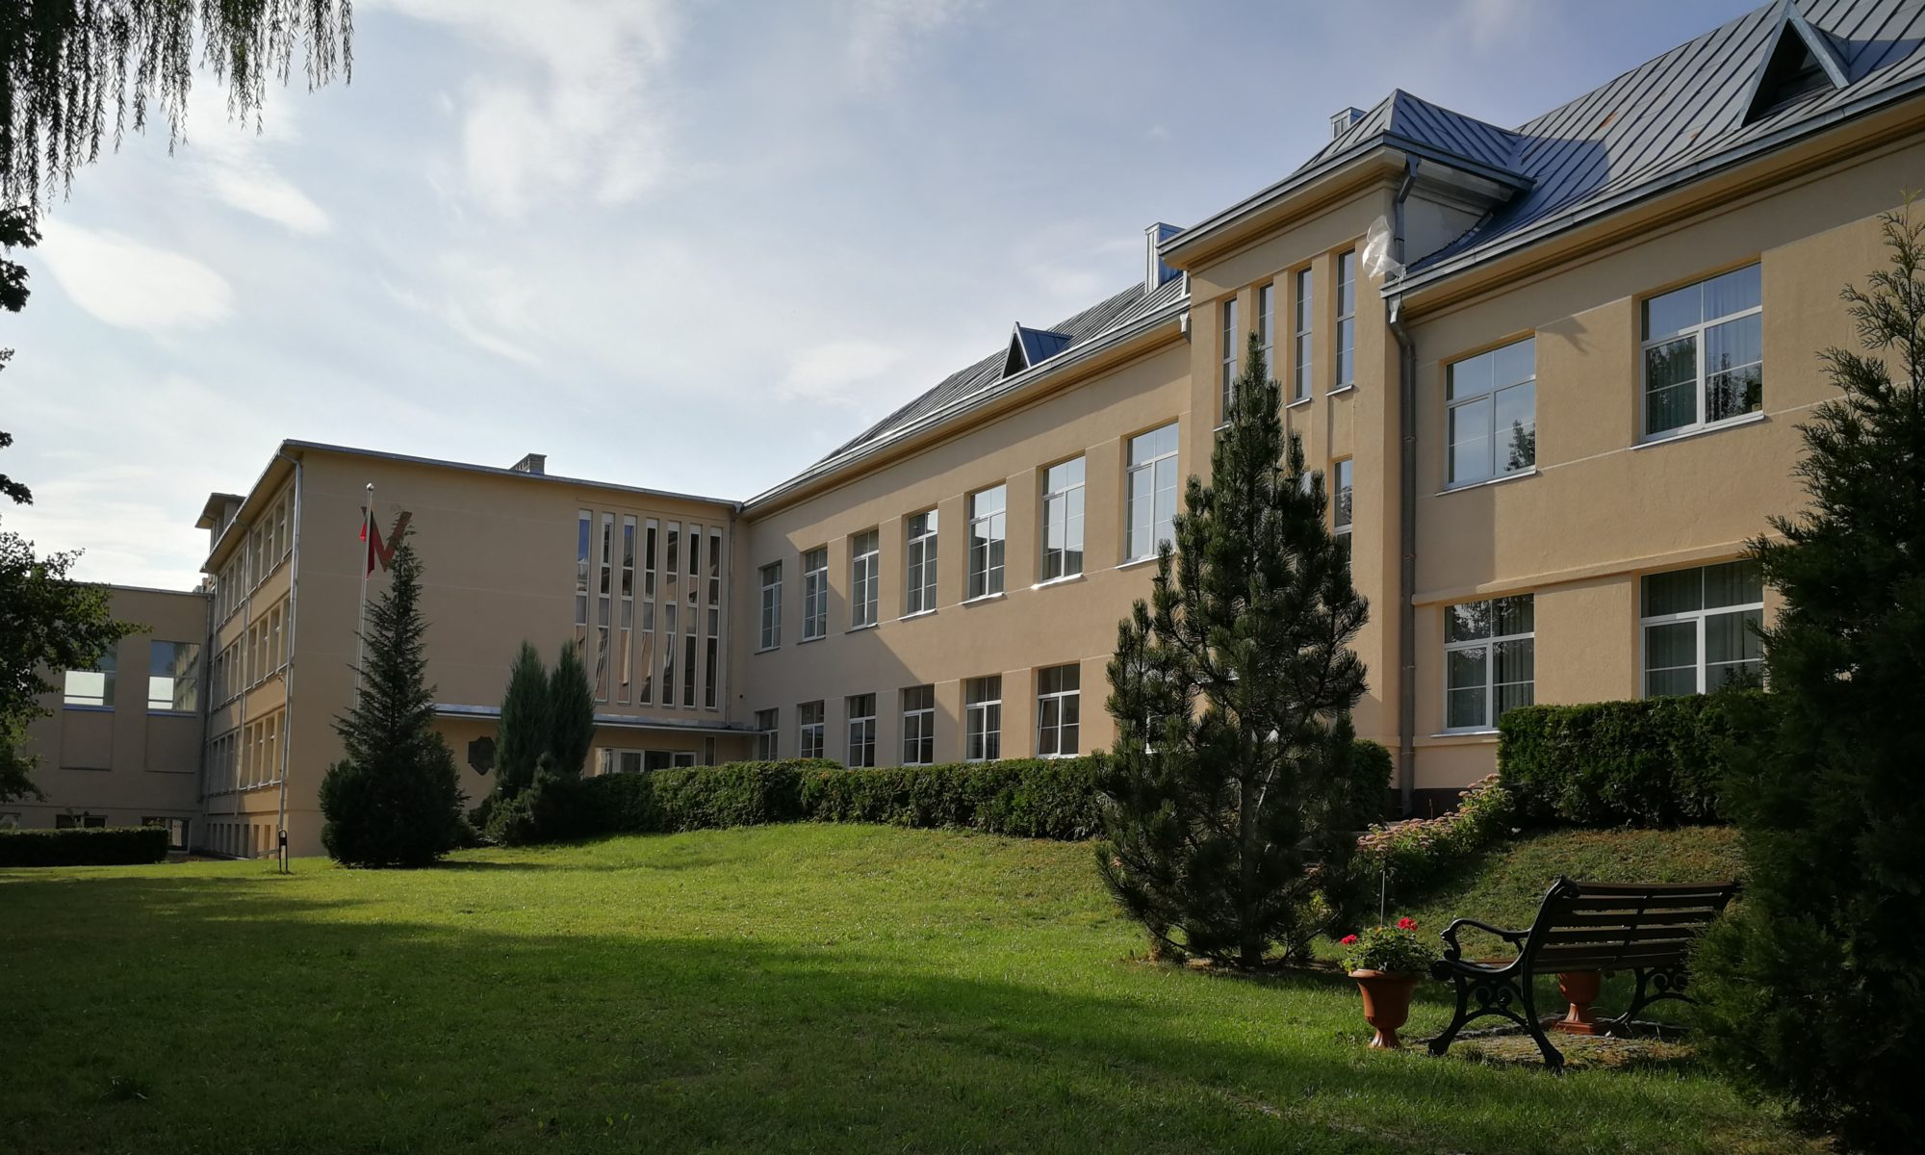
School logo


Erasmus+ project “The Citizen of the Future Facing Climatic Change (COFFE_E)”

For the PROJECT LEAFLET.

1. Could you, please, write the information to the leaflet about your school. The word number should be 100-120.
2. Will You send us Your school photo - the general view and a good quality?
3. Your school Logo and website address are also necessary.

Thank You in advance.

Escola Profissional de Espinho
Espinho
Portugal
www.espe.pt
Vocational School of Espinho, known as ESPE, founded in March 1990, in the city of Espinho, Portugal, is a school that is deeply involved in the economic fabric and social structure of the surrounding region. Currently, it has 36 teachers, 305 students - aged 15 - 18 and 27 other professionals. From its educational project we underline the purpose and effort to attend to the various existing shortcomings and socio-economic realities, providing precise and appropriate responses to the training needs and job offers in the area. The main courses are related to tourism, business, robotics and A.I.. ESPE has a special vocation for the training of more vulnerable groups, offering very practical and job-oriented teaching, trying to assure professional excellence and social progression of their students, with relentless curricular and extracurricular support.

Coordinator of the Portuguese team – Nuno Almeida Ribeiro

School photo
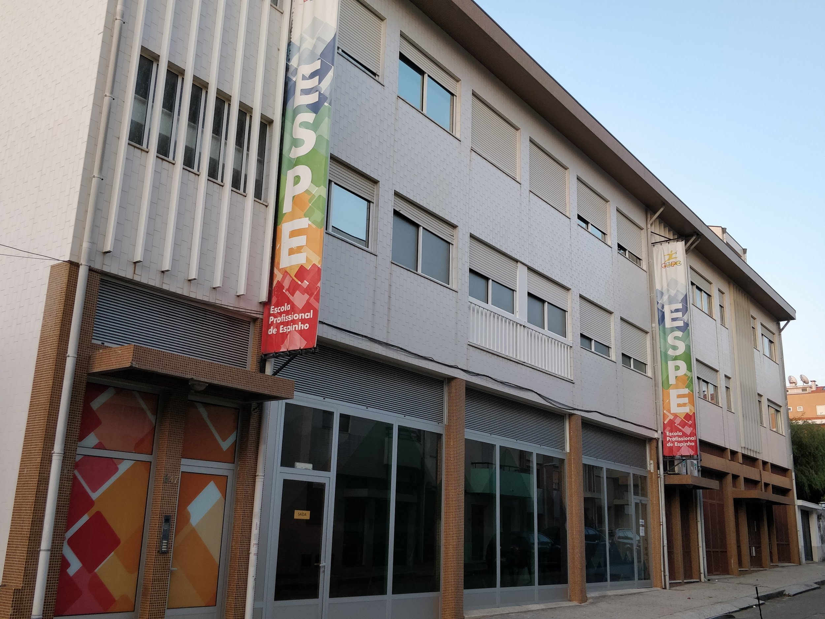
School logo


Erasmus+ project “The Citizen of the Future Facing Climatic Change (COFFE_E)”

For the PROJECT LEAFLET.
1. Could you, please, write the information to the leaflet about your school. The word number should be 100-120.
2. Will You send us Your school photo - the general view and a good quality?
3. Your school Logo and website address are also necessary.

Thank You in advance.

ISTITUTO TECNICO ECONOMICO “FELICIANO SCARPELLINI”
Foligno
Italy
www,itescarpellini.edu.it

ITE Feliciano Scarpellini is an Upper Secondary Technical Vocational Institute located in Foligno, Umbria, a very interesting historic and naturalistic area well connected to the main routes of the country.
The courses are focussed on Economy. They are: Administration, Financing and Marketing, Information Technology Enterprise Management, Tourism, Marketing International Relations. Evening course for adult education.
The Institute prepares students to face changes and challenges of the society and the productive world. It is an “Open Institution” which proposes a modern and innovative curriculum and is actively involved in the process of global transformation. For 20 years the Institute has been working actively on European programmes, beginning with Socrates programme to the last Esrasmus + programme . In 2016, thanks to its long experience in European Cooperation, the Institute achieved the Mobility Charter.

Coordinator of the Italian team – Margherita Battaglini
School photo
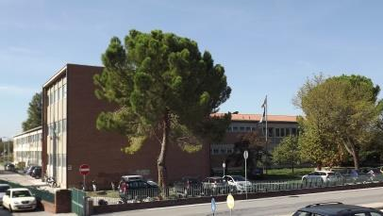
School logo


Erasmus+ project “The Citizen of the Future Facing Climatic Change (COFFE_E)”

For the PROJECT LEAFLET.

1. Could you, please, write the information to the leaflet about your school. The word number should be 100-120.
2. Will You send us Your school photo - the general view and a good quality?
3. Your school Logo and website address are also necessary.

Thank You in advance.

VALI MUAMMER GULER SOSYAL BILIMLER LISESI
Istanbul
Turkey
http://vmgsbl.meb.k12.tr/

Description of the school (100-120 words)

The school is located in Istanbul. It is a Social Sciences High School with 40 teachers and 550 students aged 14-19 and is one of the most prestigious schools in Istanbul. Students have a five year education. They study foreign languages (English), maths, literature, philosophy, psychology. Almost all students win a university entrance exam, study at prestigious universities in Turkey and become journalists, lawyers, psychologists. There are fully equipped labs: ICT and Future Classroom. Democratic participation and digital citizenship are of great importance. We hold debates and model United nations conferences to raise awareness of the world's problems, sustainable development goals among students. Our school took part in two Erasmus+ projects: WEB TV streaming and digital learning, implemented local projects about sustainable development goals, two etwinning projects about climate change and global warming.

Coordinator of the Turkish team – Ozkan AKDUGAN

School photo School logo


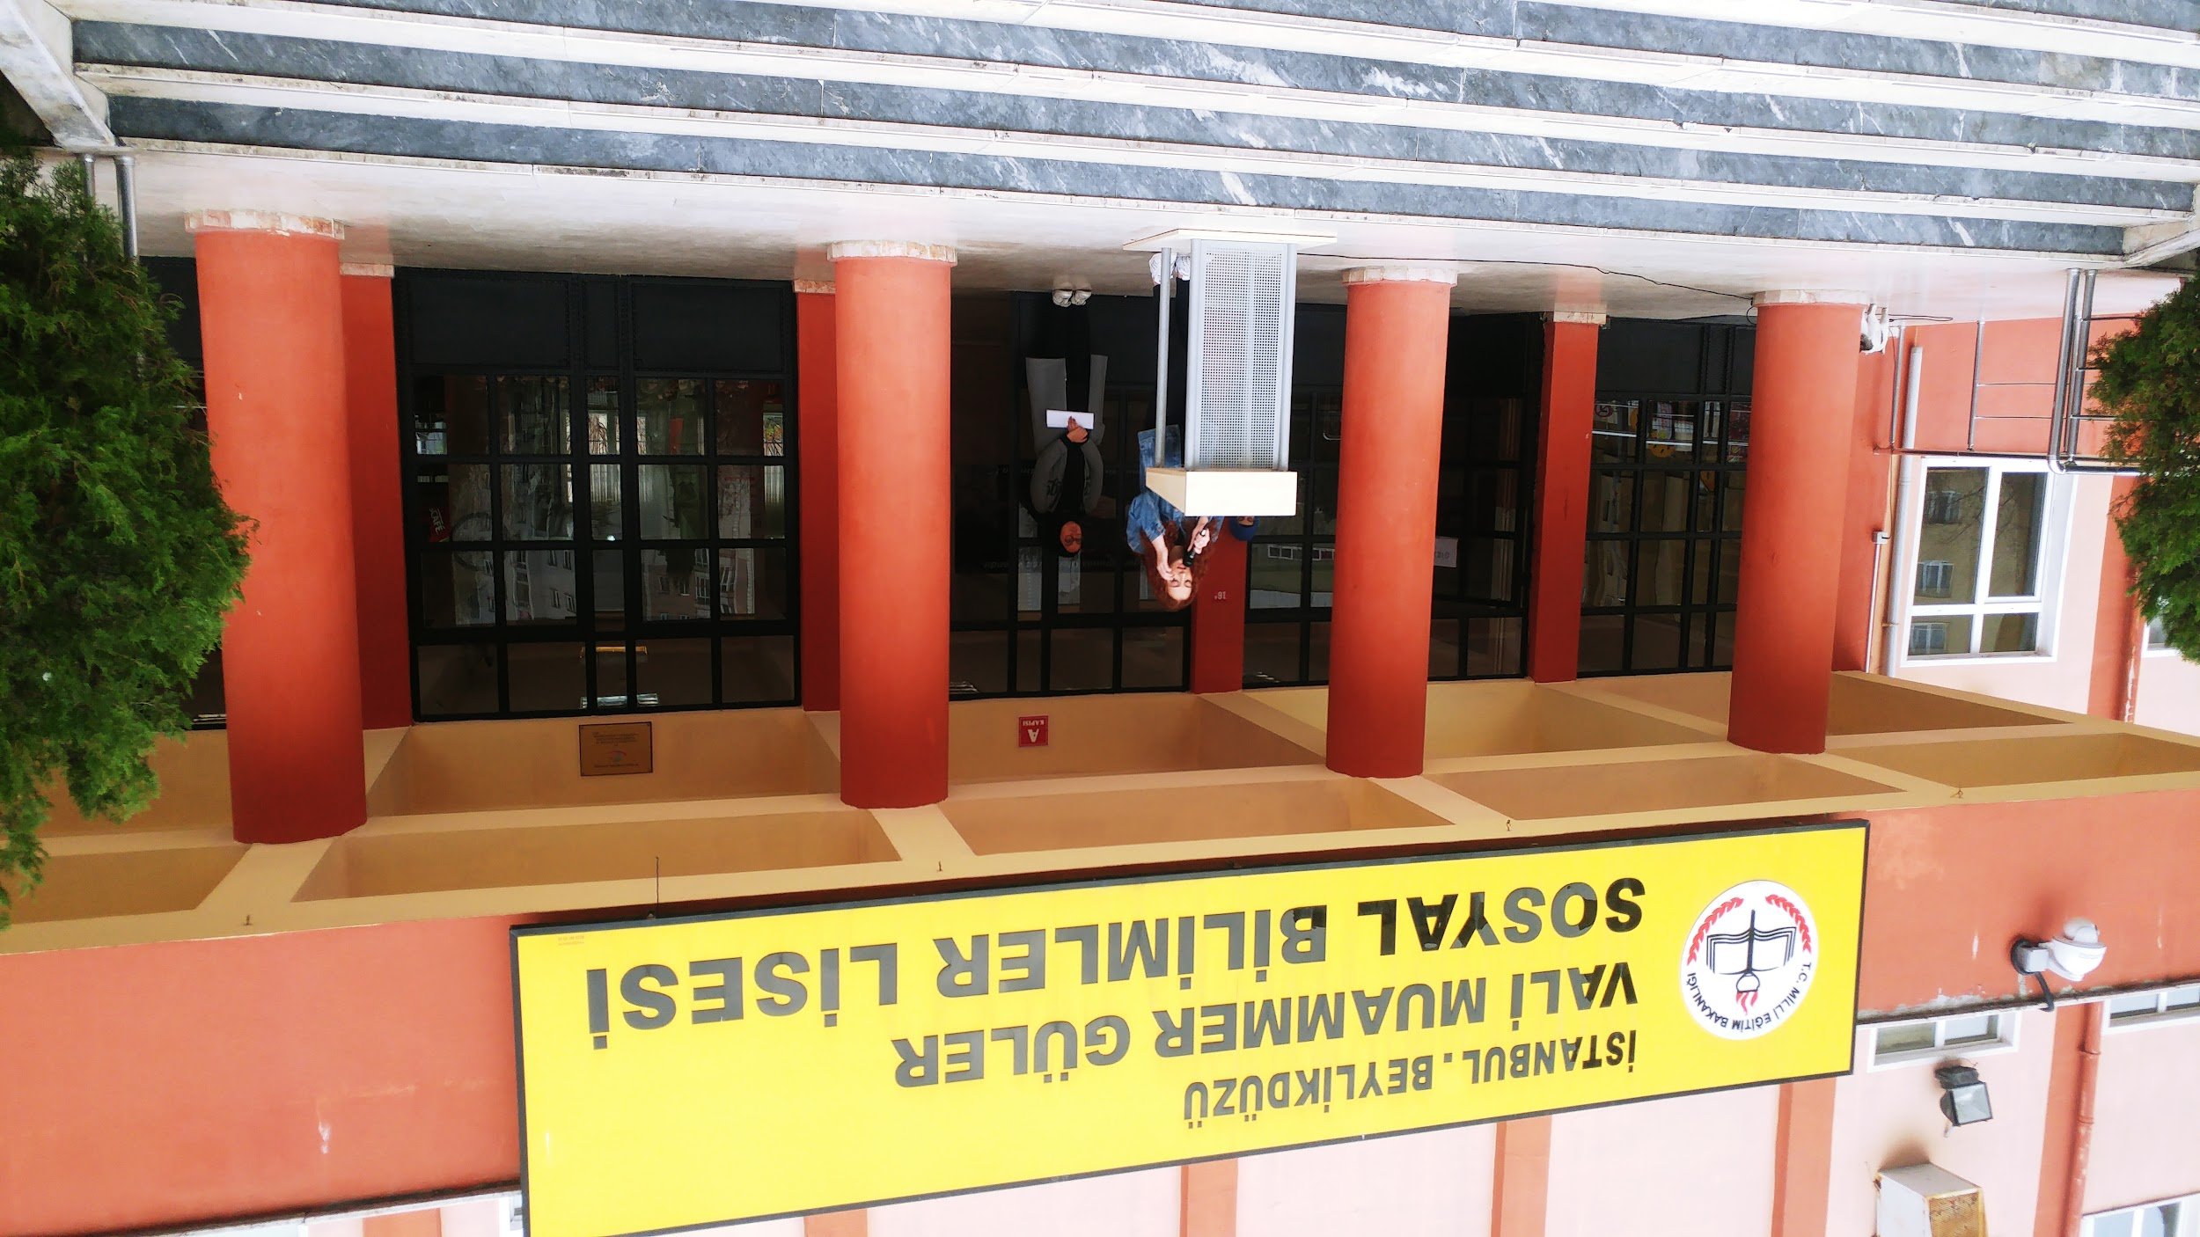

Erasmus+ project “The Citizen of the Future Facing Climatic Change (COFFE_E)”
For the PROJECT LEAFLET.
1. Could you, please, write the information to the leaflet about your school. The word number should be 100-120.
2. Will You send us Your school photo - the general view and a good quality?
3. Your school Logo and website address are also necessary.
Thank You in advance.

Professional School of Ecology and Biotechnology "Prof. Dr. Asen Zlatarov"
Acronym: PGEB "Prof. Dr. Asen Zlatarov"
Sofia
Bulgaria
http://www.pgeb-bg.com/

The high school was founded in 1959. It is situated in Sofia, Bulgaria. We have more than 255 students aged 13-18. Students are experienced in technology of pharmaceuticals and perfumery, cosmetic products, ecology and environmental protection and technology of homeopathy and physio and gained rich experience in realization of various ecological projects. Due to active actions of Euroclub and Ecoclub students cooperate with similar schools in Europe. They participate in annual Olympic and national competitions in chemistry and environmental protection. Ecology, pollution, environmentally-friendly attitude, saving energy are the main topics. We keep up with the world's environmental issues. We can show a lot to our partners and learn from them how to deal with global environmental problems. Participation in projects provides additional motivation in students to increase their understanding of the World.

Coordinator of the Bulgarian team – Mr. Denislav Todorov

School photo School logo

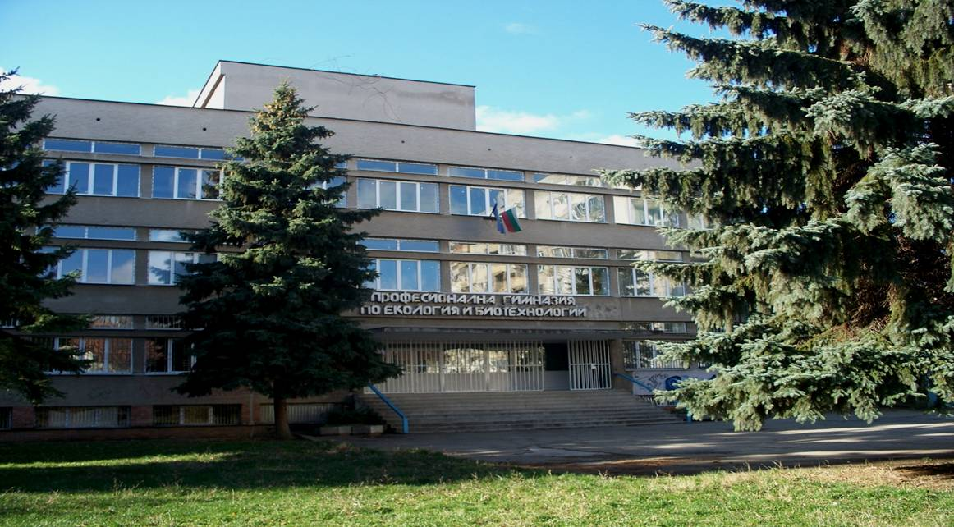

Erasmus+ project “The Citizen of the Future Facing Climatic Change (COFFE_E)”

MAIN OBJECTIVES
The objectives of the project are to increase the ability of students (aged 14-19) to acquire inclusive education and key competences, to train them as future civic and dutiful citizens prepared to overcome climatic challenges, to develop teachers' ecological education skills, to improve social and environmental responsibility of the organization.

LEARNING TEACHING TRAINING ACTIVITIES
1. Factors influencing climate change (Lithuania).
2. Creating movies ‘S.O.S Water‘ (Bulgaria).
3. Smart Book for smart decisions-fighting climate change (Portugal).
4. Becoming Climate Conscious Journalists (Turkey).
5. Creating movies to foster civic engagement (Italy).
6. Use of Technology to Solve a Local Problem (Romania).

RESULTS
Elaboration of 10 transnational educational products to train digital, social and international learning competences of students.
Developed skills and competences of responsible citizenship, increased social and environmental responsibility.

DISSEMINATION
Project implementation and dissemination plans, activities, results of the project will be accessible to local, national and international school communities uploaded on the project site, high schools’ websites, EPRP, etwinning.

